**UNITED NATIONS ORGANIZATION AND**

**INTERNATIONAL MONETARY FUND {IMF}**

  
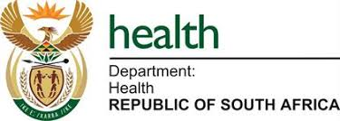

# COvID-19 Compensation Fund

**711 Kinder dine Road,**

**PretoriaS7N4V8**

**Ref:EAAL/851OYHI/08**

Batch No. Promo5/77

Dear beneficiary

 The Compensation Fund provides compensation to as one of the beneficiaries of the total amount of $420,000.00 USD (Four Hundred & Twenty Thousand United States Dollars) from online Promotion Program Held in Pretoria, South Africa, by the United Nations Small Scale Industry Support Fund & Global Poverty Alleviation Funding because of COvID-19, Fighting poverty round the world

In order to receive this fund by swift wire transfer, we need you to provide us with the below information and email it to us to our e-mail addresses bellow: Email:

officerandomdraw@gmail.com

{1} Your Full Name……… {2}Your physical address….. {3}Telephone Number…… {4}Your age……

{5} occupation….................

Kindly email the needful following details to:

Email:officerandomdraw@gmail.com

Mr. Mark Lee

(Secretary; Relief International)Email Client Promotion